|  |
| --- |
| MCDIGITAL @ MIDDLESBROUGH COLLEGE |
| PRINCE2 PROJECT OVERVIEW |
|  |
|  |
|  |
| **Stuart Goodman** |

**13/12/2022**

Liam G Curry

|  |
| --- |
|  |

**Information Technology- Level 3 (Including Networking & Security and Application and Web Development)**

# Table of Contents

Table of Contents 1

1 Introduction 2

2 Topics 3

2.1 Our Team 3

2.2 User Experience 3

2.3 Why do we need to undertake this project? 4

2.4 What are the business benefits? 4

2.5 Risks 4

2.6 Potential costs? 4

2.7 How long will the project take? 4

2.8 Purpose? 5

2.9 Acceptance method and responsibilities 5

2.10 Customer Quality Expectations 5

2.11 Product Objectives 5

2.12 Pre-project phase 5

2.13 Planning phase 6

2.14 Sir Model 6

2.15 Code Structure 7

2.16 Design phase 8

2.17 Development Phase 9

2.18 Test Case 9

3 Conclusion 9

4 Reference List 10

# Introduction

In this report, I will be discussing the specific designation, design, and implementation of PRINCE2 into my project and hope to show the specific changes and modifications made to the project regarding PRINCE2 but also to show the modifications made to our planning and documentation plans.

This report is subject to bias and opinions formed on a basis of personal views and beliefs since this is not an overview of the PRINCE2 methodology, rather a documented experience and review of the methodology and any other factors included.

# Topics

## Our Team

Our direct team is comprised of two people, that being me, Stuart Goodman, and Lewis Perry. Our direct overall team are not directly experienced, and it is our first time developing something of this calibre before.

Obviously, because of this direct small team, our overall project hierarchy is very much simplistic and non-complex and making systems regarding hierarchy very much simplified.

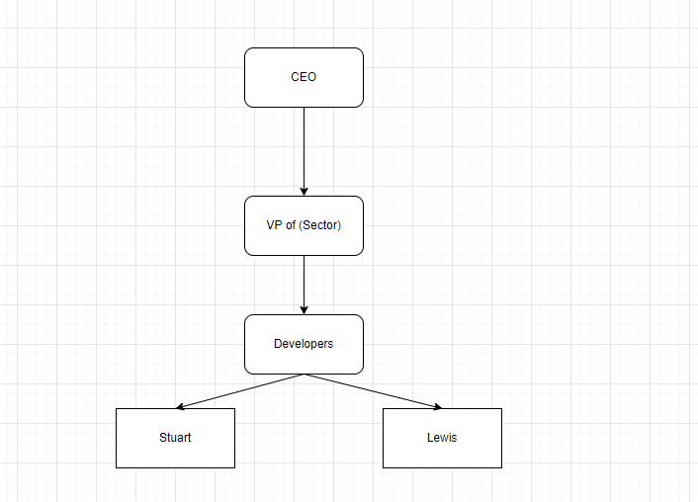

## User Experience

We want our user experience to be positive and efficient. We would also like it to be simple, effective, and simplistic in nature to make sure that potential users have a good experience and recommend the overall product/application to other members of the public. Our general experience would follow these specific steps:

1. Go to the website.
2. Select the downloads page.
3. Download the application (and optionally the documentation).
4. Move the application to a specific location on your computer (optional).
5. Open the application.
6. Enter a username.
7. Enter your custom values within the corresponding boxes.
8. Click the “run” button.
9. Wait until the application generates your values.
10. View the displayed graph.
11. Download or copy the graph (optional).
12. Close the graph.
13. Changes the values again and run the application.
14. Close the application when the user finished.

## Why do we need to undertake this project?

We need to undertake this overall project because without the completion of this project, or at least the documentation, we will be unable to achieve a passing mark regarding this specific assessment module. We also need to undertake this project as it will allow us to develop our overall programming, team collaboration and problem-solving skills which may prove beneficial when hunting for future employment.

## What are the business benefits?

There are not many direct business benefits, mainly because this is not for a business, and we do not work in a legitimate or existing organisational body in any capacity. Though only main benefits are purely individualistic, for example developing our personal skills and the general ability to market ourselves to future employers.

## Risks

There are a few current active risks in relation to the overall project. Those risks are as a follow:

* Time constraints: Our overall time constraints are going to cause long term issues in our overall project. We do not have a major amount of time and could be effective
* Lack of full completion: We have run into new errors that are making it difficult regarding completing the project. We will try to fix these, but we may end up with a non-complete or erroring product.

## Potential costs?

The only potential costs that could be presence in our development cycle is us having to pay for select features to allow for our application to function. As of current though, we have not had to spend any value of money in any regard.

## How long will the project take?

The project will most likely take the maximum amount of time up until the stipulated deadline, this is partly because of the fact it is the first time we have developed anything like this specific scope as well as the fact that we are relatively in-experienced.

## Purpose?

The purpose of the project is to create and develop a specific application/software which can simulate viral infections using the SIR infection model. It will also, as a sub add on, inform people about viral transmissions and the specific attributes related to how a virus transmits.

## Acceptance method and responsibilities

The responsibility will be along all members of the team to quality check, analysis, fix and update specific parts of the application/software and make sure that the project is the best it can possibly it can be.

## Customer Quality Expectations

To validate customer quality and the systems, a form can be sent out to users to ask for feedback, or feedback can be interpreted from specific sections inside of the Github repository. There can also be a feedback system built inside of the application.

I believe that the customer will be expecting the product to work efficiently, and not harm the integrity of their overall systems or functions or utilise too much of the present system resources.

## Product Objectives

To validate customer quality and the systems, a form can be sent out to users to ask for feedback, or feedback can be interpreted from specific sections inside of the Github repository. There can also be a feedback system built inside of the application.

I believe that the customer will be expecting the product to work efficiently, and not harm the integrity of their overall systems or functions or utilise too much of the present system resources.

This section will be updated as required because project objectives may change based on changes in external markets, clients, or internal stipulations. As of current, the required objectives that the application need to complete are as followed:

* The project needs to have a completed documentation regardless of the state of the project whether in quality, quantity, or completion.
* The project needs to, if possible, be able to complete basic required tasks in processing data and producing the desired output.
* The project should be able to be cost effective and not be resource intensive.

## Pre-project phase

This specific phase of the project was dedicated to specific actions that should be completed before the project was fully started. Although this was not specifically completed when it should have been. The specific pre-project phase includes finding and validating potential ideas to see how visible they are in long-term development and production.

We did not directly spend too long on the direct part of this project. This is mainly because we did not do a lot of direct pre-project planning because we decided to it would be better to plan as we moved with the project rather.

## Planning phase

In the planning phase, we discussed that we would have a defined website that will be accessible to the public, which will also be maintained, act as a vector of obtainment to our designed application.

Our designed application will relate to the Sir Model and will hopefully run an effective and customisable model to allow for users to run accurate and effective simulations of the model with customised variables. I ended up creating a wireframe for the application, and then decided to not directly plan out the website as I decided it would be more beneficial to build parts of the website, and change the design based on the parts that I directly built.

The planning phase mainly acts as a phase for laying the foundations of the project to allow for us to establish and develop our ideas into functionals methods and processes that we can then further expand upon and scale to what the company needs.

## Sir Model

Before we discuss any further, it may be beneficial for the you to directly understand what the overall Sir model is.

The Sir Model is a compartmental model standing for Susceptible, Infectious, Recovered. This models’ main goal is to allow for scientists to view a scalable model to assess and infer how far a pandemic/epidemic has progressed and the effects that the potential cures and stipulates are having.

Susceptible is “The number of susceptible individuals. When a susceptible and an infectious individual come into "infectious contact", the susceptible individual contracts the disease and transitions to the infectious compartment.” Infectious is “the number of infectious individuals. These are individuals who have been infected and are capable of infecting susceptible individuals.” And finally, R “for the number of removed (and immune) or deceased individuals. These are individuals who have been infected and have either recovered from the disease and entered the removed compartment or died. It is assumed that the number of deaths is negligible with respect to the total population. This compartment may also be called "recovered" or "resistant".”

The entire model is based on multiple mathematic functions that will allow the research to collect and identify key information to gain an accurate overview of the ongoing epidemic/pandemic in the region/location.

The reason we decided to use the Sir Model for our project was because of the fact it incorporated the aspect of biology (science) with computing (digital) which we thought would be very beneficial and enjoyable to do.

## Code Structure

We should also discuss the coding architecture; I personally feel like this would be very beneficial to do as to show what we’re planning to do. In terms of the application, we will be using Python for the development of our application.

In theory, the application will be using external packages with pip, and importing using the import feature. We will also be utilising other data files like “.json”. The file type will allow us to store our data in an easily readable format regarding entries.

Apart from that, the code structure has not been directly pre-planned and will be discussed upon further in the project as the time and development progresses.

We will also be using different programming languages to develop the same overall application if we have the time. This doesn’t really provide too any direct benefits for our project, it’s just an added challenge that might be beneficial for us as a learning experience regarding the different languages.

In terms of the website, that utilises the HTML and Typescript. The Typescript is obtained from external files and not integrated inside of a <script> tag. The website also uses Tailwindcss as the direct CSS and utilises Sanity as the CMS (Content Management System). The website also utilises formatting with Prettier as far as I am aware.

For our GUI (Graphical User Interface), we will be utilising the python GUI modules that can be implemented. Those are customtkinter and tkinter. We’ve also changed how we will using other files, we will not be using “.json” files.

The code will look something like this:

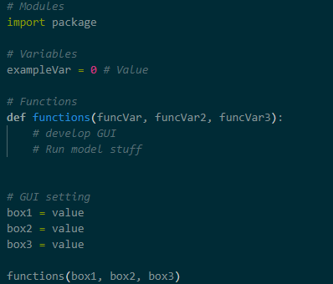

## Design phase

The design phase was not directly isolate but itself. It was more so continually improved upon as the project developed. This was because as the project changed and became more defined and clearer, our original designs or scale was found to be non-usable.

This wasn’t applicable for the website, as the web site was not directly planned out and was more developed and change over time in increments by me when I was developing it. Though this is directly applicable for the application.

This was applicable for the application though. We create theoretical methods and designs of what we could do for the application and how we could directly set out the application. But after a bit of stress testing with potential issues and difficulties, we changed select parts to make sure that the collaboration incorporation was efficient and allowed us to complete all our direct designed features when we get to the direct development phase.

A design of the of the project application can be found below:

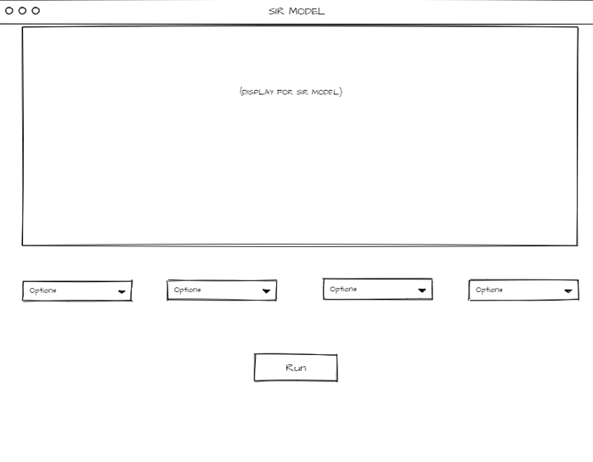

There is also a direct document dedicated for the design of the overall product that will also be uploaded independently. This upload is exclusive to a local member and will not be visible on the GitHub.

Our overall design of the project has directly changed. We will no longer be utilising this design. This is because of the programming constraints within the GUI, so we will be using a stacked variant of the design and opening a new graph tab when the program has completed running the model.

## Development Phase

The development phase has proven more difficult than previously expected. The model is becoming problematic regarding implementation, as it is seemingly more difficult than previously expected. We will be looking at this further on the 18th of April, when were back in college to address the issue.

The GUI has proven easier to do. We managed to sort that out relatively effectively and efficiently. Although, we have had to stop developing it (specifically the graph) to focus on the implementation of the model. Once the model is completed, we will move further onto the graph.

## Test Case

On a different document.

# Conclusion

This is my general conclusion for the documentation of my overall design project and application.

# Reference List